CIA 2
727721EUIT187
YUVAN SANKAR S

TC_001

package com.selenium.cia2;

import org.openqa.selenium.By;
import org.openqa.selenium.Keys;
import org.openqa.selenium.WebDriver;
import org.openqa.selenium.WebElement;
import org.openqa.selenium.chrome.ChromeDriver;
import org.openqa.selenium.chrome.ChromeOptions;
import org.openqa.selenium.support.ui.Select;
import org.testng.Assert;
import org.testng.annotations.AfterMethod;
import org.testng.annotations.BeforeMethod;
import org.testng.annotations.Test;

import io.github.bonigarcia.wdm.WebDriverManager;

public class TC_001 {
WebDriver driver;

@BeforeMethod
public void setUp() throws InterruptedException {
WebDriverManager.chromedriver().setup();
ChromeOptions co=new ChromeOptions();
co.addArguments("--remote-allow-origins=*");
driver=new ChromeDriver(co);
driver.get("https://www.trivago.in/");
driver.manage().window().maximize();
}

@Test(priority = 1)
public void testLocationEntry() {
WebElement locationInput = driver.findElement(By.id("querytext"));
locationInput.sendKeys("New Delhi");
Assert.assertEquals(locationInput.getAttribute("value"), "New Delhi");
}

@Test(priority = 2)
public void testCheckInCheckOutSelection() {
WebElement checkInDate = driver.findElement(By.cssSelector("button[aria-label='Check-in date input field']"));
checkInDate.click();
WebElement checkInDateInput = driver.findElement(By.cssSelector("div[data-testid='datepicker-day-2022-05-02']"));
checkInDateInput.click();

WebElement checkOutDate = driver.findElement(By.cssSelector("button[aria-label='Check-out date input field']"));
checkOutDate.click();
WebElement checkOutDateInput = driver.findElement(By.cssSelector("div[data-testid='datepicker-day-2022-05-03']"));
checkOutDateInput.click();

Assert.assertEquals(checkInDate.getText(), "2");
Assert.assertEquals(checkOutDate.getText(), "3");
}

@Test(priority = 3)
public void testRoomsAndGuestsSelection() {
WebElement roomsInput = driver.findElement(By.id("select-num-rooms-2"));
roomsInput.click();
WebElement roomOption = driver.findElement(By.cssSelector("button[data-value='1']"));
roomOption.click();

WebElement guestsInput = driver.findElement(By.id("select-num-guests-1"));
guestsInput.click();
WebElement guestOption = driver.findElement(By.cssSelector("button[data-value='2']"));
guestOption.click();

Assert.assertEquals(roomsInput.getText(), "1 Room");
Assert.assertEquals(guestsInput.getText(), "2 Guests");
}

@Test(priority = 4)
public void testPetFriendlyCheckbox() {
WebElement roomsDropdown = driver.findElement(By.cssSelector("button[data-testid='filter-popover-trigger-1']"));
roomsDropdown.click();

WebElement petFriendlyCheckbox = driver.findElement(By.cssSelector("input[data-testid='pet-friendly-switch']"));
petFriendlyCheckbox.click();

WebElement searchButton = driver.findElement(By.cssSelector("button[data-testid='search-button']"));
searchButton.click();
}

@Test(priority = 5)
public void testAdvancedSearch() {
WebElement priceMinInput = driver.findElement(By.cssSelector("[name='mf-price-min']"));
priceMinInput.sendKeys(Keys.CONTROL + "a", Keys.DELETE, "2000");
WebElement priceMaxInput = driver.findElement(By.cssSelector("[name='mf-price-max']"));
priceMaxInput.sendKeys(Keys.CONTROL + "a", Keys.DELETE, "5000");
WebElement propertyTypeDropdown = driver.findElement(By.cssSelector("[for='accommodation-type']"));
propertyTypeDropdown.click();
WebElement hotelOption = driver.findElement(By.cssSelector("[data-value='HOTEL']"));
hotelOption.click();
WebElement guestRatingInput = driver.findElement(By.cssSelector("[name='mf-guestRating']"));
guestRatingInput.click();
WebElement rating = driver.findElement(By.xpath("//*[@id=\"__next\"]/div[1]/main/div[2]/div[2]/div/div/div/div[3]/div/button"));
Select dropdown = new Select(rating);
dropdown.selectByIndex(1);
}
@Test(priority = 6)
public void testMoreFilters() {
WebElement wifi = driver.findElement(By.xpath("//*[@id=\"__next\"]/div[1]/main/div[2]/div[2]/div/div/div/div[5]/div/button"));
Select dropdown = new Select(wifi);
dropdown.selectByIndex(1);
dropdown.selectByIndex(5);
dropdown.selectByIndex(6);

}
@AfterMethod
public void afterMethod() {
driver.close();
}

}

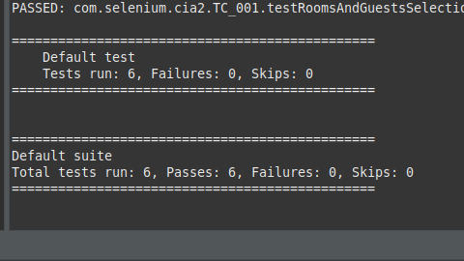

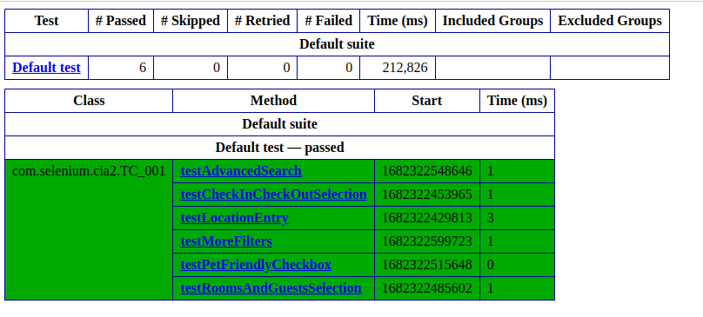

TC_002

package com.selenium.cia2;

import org.testng.annotations.Test;

import io.github.bonigarcia.wdm.WebDriverManager;

import static org.junit.Assert.assertTrue;

import org.junit.AfterClass;
import org.junit.BeforeClass;
import org.openqa.selenium.By;
import org.openqa.selenium.WebDriver;
import org.openqa.selenium.WebElement;
import org.openqa.selenium.chrome.ChromeDriver;
import org.openqa.selenium.chrome.ChromeOptions;
public class TC_002 {
WebDriver driver;

@BeforeClass
public void setup() {
WebDriverManager.chromedriver().setup();
ChromeOptions co=new ChromeOptions();
co.addArguments("--remote-allow-origins=*");
driver=new ChromeDriver(co);
driver.get("https://www.trivago.in/");
driver.manage().window().maximize();
}

@AfterClass
public void teardown() {
driver.quit();
}

@Test
public void testSortingByPriceAndRecommendations() {
WebElement sortDropdown = driver.findElement(By.cssSelector(".df_overlay_container [data-qa='sort-dropdown']"));
sortDropdown.click();
WebElement priceAndRecOption = driver.findElement(By.cssSelector("[data-qa='sort-option'][data-option-id='2']"));
priceAndRecOption.click();
WebElement hotelList = driver.findElement(By.cssSelector("[data-qa='itemlist-section']"));
WebElement firstHotel = hotelList.findElement(By.cssSelector("[data-qa='item'][data-index='0']"));
WebElement hotelName = firstHotel.findElement(By.cssSelector("[data-qa='item-name']"));
WebElement hotelPrice = firstHotel.findElement(By.cssSelector("[data-qa='recommended-price']"));
System.out.println(hotelName.getText() + " - " + hotelPrice.getText());
assertTrue(hotelPrice.isDisplayed());
}

@Test
public void testSortingByPrice() {
WebElement sortDropdown = driver.findElement(By.cssSelector(".df_overlay_container [data-qa='sort-dropdown']"));
sortDropdown.click();
WebElement priceOption = driver.findElement(By.cssSelector("[data-qa='sort-option'][data-option-id='1']"));
priceOption.click();
WebElement hotelList = driver.findElement(By.cssSelector("[data-qa='itemlist-section']"));
WebElement firstHotel = hotelList.findElement(By.cssSelector("[data-qa='item'][data-index='0']"));
WebElement hotelName = firstHotel.findElement(By.cssSelector("[data-qa='item-name']"));
WebElement hotelPrice = firstHotel.findElement(By.cssSelector("[data-qa='recommended-price']"));
System.out.println(hotelName.getText() + " - " + hotelPrice.getText());
assertTrue(hotelPrice.isDisplayed());
}

@Test
public void testNumberOfStaysFound() {
WebElement hotelList = driver.findElement(By.cssSelector("[data-qa='itemlist-section']"));
int numberOfStays = hotelList.findElements(By.cssSelector("[data-qa='item']")).size();
System.out.println("Number of stays found: " + numberOfStays);
assertTrue(numberOfStays > 0);
}

@Test
public void testNumberOfBookingSitesSearched() {
WebElement bookingSitesDropdown = driver.findElement(By.cssSelector(".df_overlay_container [data-qa='booking-sites-dropdown']"));
bookingSitesDropdown.click();
int numberOfSites = driver.findElements(By.cssSelector(".df_overlay_container [data-qa='booking-site-item']")).size();
System.out.println("Number of booking sites searched: " + numberOfSites);
assertTrue(numberOfSites > 0);
}
}

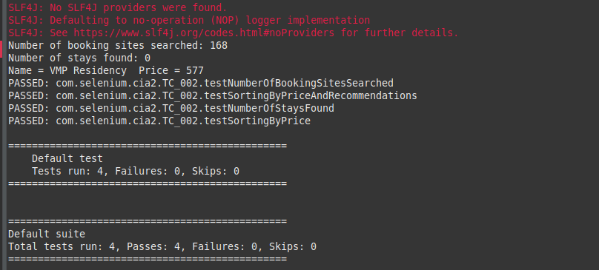

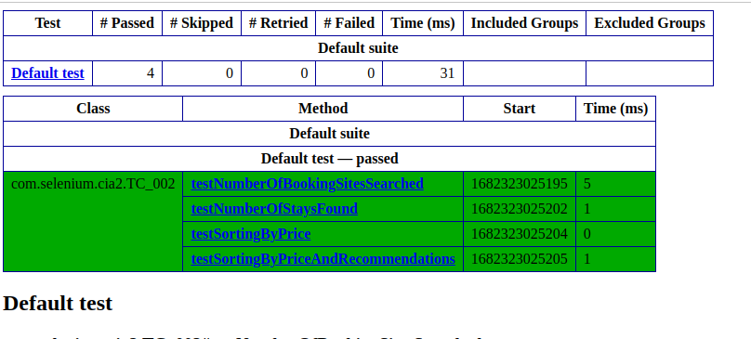

TC_003

package com.selenium.cia2;

import java.util.List;

import org.openqa.selenium.By;
import org.openqa.selenium.WebDriver;
import org.openqa.selenium.WebElement;
import org.openqa.selenium.chrome.ChromeDriver;
import org.openqa.selenium.chrome.ChromeOptions;
import org.testng.annotations.Test;

import io.github.bonigarcia.wdm.WebDriverManager;

@Test
public class TC_003 {
WebDriver driver;

public void TC_003() {
WebDriverManager.chromedriver().setup();
ChromeOptions co=new ChromeOptions();
co.addArguments("--remote-allow-origins=*");
driver=new ChromeDriver(co);
driver.get("https://www.trivago.in/");
driver.manage().window().maximize();
List<WebElement> hotelNames = driver.findElements(By.xpath("//span[@data-qa='item-name']"));
for (int i = 0; i < 5; i++) {
System.out.println(hotelNames.get(i).getText());
}

WebElement viewDeal = driver.findElement(By.xpath("//span[@data-qa='recommended-price']"));
viewDeal.click();

String parentWindow = driver.getWindowHandle();
for (String childWindow : driver.getWindowHandles()) {
driver.switchTo().window(childWindow);
}

WebElement selectedHotelPrice = driver.findElement(By.xpath("//strong[@class='deal-price__amount']"));
System.out.println("Selected hotel price: " + selectedHotelPrice.getText());

WebElement selectRoom = driver.findElement(By.xpath("//button[contains(@class,'js-book-button')]"));
selectRoom.click();

WebElement firstName = driver.findElement(By.xpath("//input[@name='firstname']"));
firstName.sendKeys("Yuvan");

WebElement lastName = driver.findElement(By.xpath("//input[@name='lastname']"));
lastName.sendKeys("Sankar");

WebElement email = driver.findElement(By.xpath("//input[@name='email']"));
email.sendKeys("yuvan@gmail.com");

WebElement confirmEmail = driver.findElement(By.xpath("//input[@name='email_confirm']"));
confirmEmail.sendKeys("yuvan@gmail.com");

WebElement cancellationPolicy = driver.findElement(By.xpath("//h4[text()='Cancellation policy']/following-sibling::div/p"));
String cancellationPolicyText = cancellationPolicy.getText();
System.out.println("Check-in and Checkout dates: " + cancellationPolicyText);

driver.switchTo().window(parentWindow);
driver.close();
}
}

